**SSW 567 - Assignment 2**

**Group 5**

Miguel Camacho

Ed Chang

Harmony Sullivan

**Assignment Description**

1. Initial Program Testing
2. Test your program
3. Try to break other teams programs
4. See if your program holds up to other teams test cases

**Summary of Results**

|  |  |  |  |
| --- | --- | --- | --- |
|  | Test Run 1 | Test Run2 | …. |
| Tests Planned |  |  |  |
| Tests Executed |  |  |  |
| Tests Passed |  |  |  |
| Defects Found |  |  |  |
| Defects Fixed |  |  |  |

The team has agreed to use Github and Tortoisegit for code collaboration. Each team member has coded their own triangle program and has submit the code to the teams repository for other members to view, compare, and critique. See screenshots below for sanity checks. Group 5 will use Google Docs to write all collaborative assignments so each member can work on the assignment independently or work the assignment as a team. Communication between the team will be facilitated through Canvas and group meetings over Google Hangouts. Time will be coordinated and agreed upon with the understanding that members of the team live in different time zones. See screenshots below for group collaboration.

**Lessons Learned**

When we develop software, the byproduct of faults gets introduced throughout the lifecycle. We need to understand the product we are producing as well as the stakeholders’ expectation so we can derive the necessary test cases to ensure the software we are delivering has least amount of faults thus reducing the failure of the overall system.

Google Hangouts works well for the team and is easy to use. The team attempted to use Google code for our repository, but was unsure how to set up and utilize it correctly. Github was used instead because prior use and experience. Currently some team members use Eclipse IDE for code creation and others use Netbeans. The team should consider agreeing on using only one type of IDE, but will continue to work with the understanding that code should work in either environment.

**Honor Pledge**

We pledge on our honor that we have not given or received any unauthorized assistance on this assignment/examination. We further pledge that we have not copied any material from a book, article, the Internet or any other source except where I have expressly cited the source.

**Test Result**

**Test Run 1**

|  |  |  |  |  |
| --- | --- | --- | --- | --- |
| Test ID | Input | Expected Results | Actual Result | Pass or Fail |
| Invalid Input Type, Real Number | 3.4 | Direction to input valid entry | InputMatchException was thrown | Failed |
| Invalid Input Type, Alpha Characters | aX | Direction to input valid entry | InputMatchException was thrown | Failed |
| Invalid Input Type, Symbols | %* | Direction to input valid entry | InputMatchException was thrown | Failed |
| Invalid Input Type, Real Number | 3.4 | Direction to input valid entry | InputMatchException was thrown | Failed |
| Invalid Triangle Inputs | 4, 10, 3 | Invalid triangle | Not a triangle | Passed |
| Valid Equilateral Triangle | 3, 3, 3 | Equilateral triangle | Equilateral triangle | Passed |
| Valid Isosceles Triangle | 2, 2, 1 | Isosceles triangle | Isosceles triangle | Passed |
| Valid Scalene Triangle | 7, 8, 9 | Scalene | Scalene | Passed |
| Valid Scalene Right Triangle | 3, 4, 5 | Right scalene triangle | Right scalene triangle | Passed |

**Test Run 2**

|  |  |  |  |  |
| --- | --- | --- | --- | --- |
| Test ID | Input | Expected Results | Actual Result | Pass or Fail |
| Invalid Input Type | 3.4 | Direction to input valid entry | InputMatchException was thrown | Passed |
| Invalid Triangle Inputs | 4, 10, 3 | Invalid triangle | Not a triangle | Passed |
| Valid Equilateral Triangle | 3, 3, 3 | Equilateral triangle | Equilateral triangle | Passed |
| Valid Isosceles Triangle | 2, 2, 1 | Isosceles triangle | Isosceles triangle | Passed |
| Valid Scalene Triangle | 7, 8, 9 | Scalene | Scalene | Passed |
| Valid Scalene Right Triangle | 3, 4, 5 | Right scalene triangle | Right scalene triangle | Passed |

**Group Collaboration 1**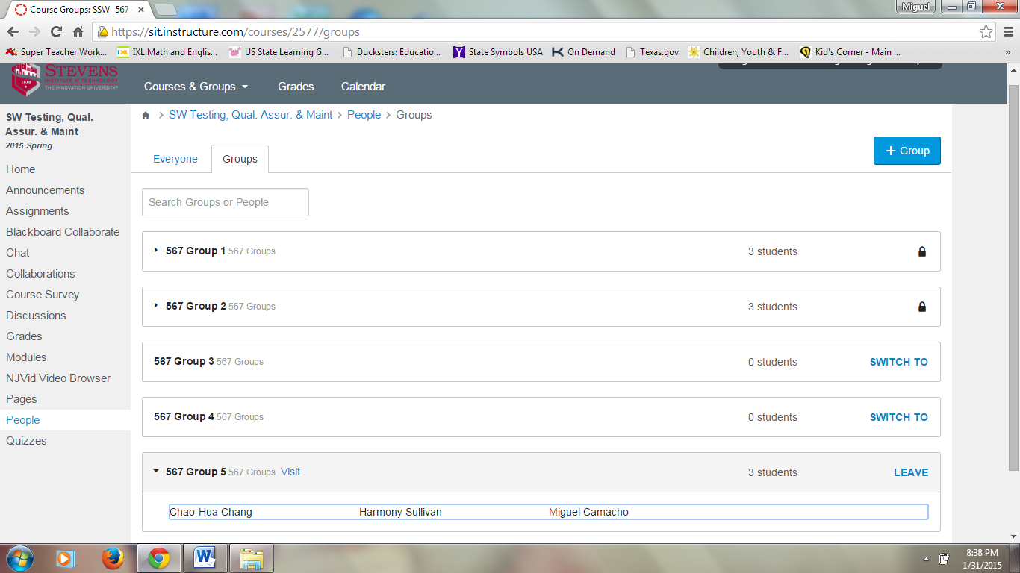

**Group 5 Canvas Screenshot**

**Group Collaboration 2**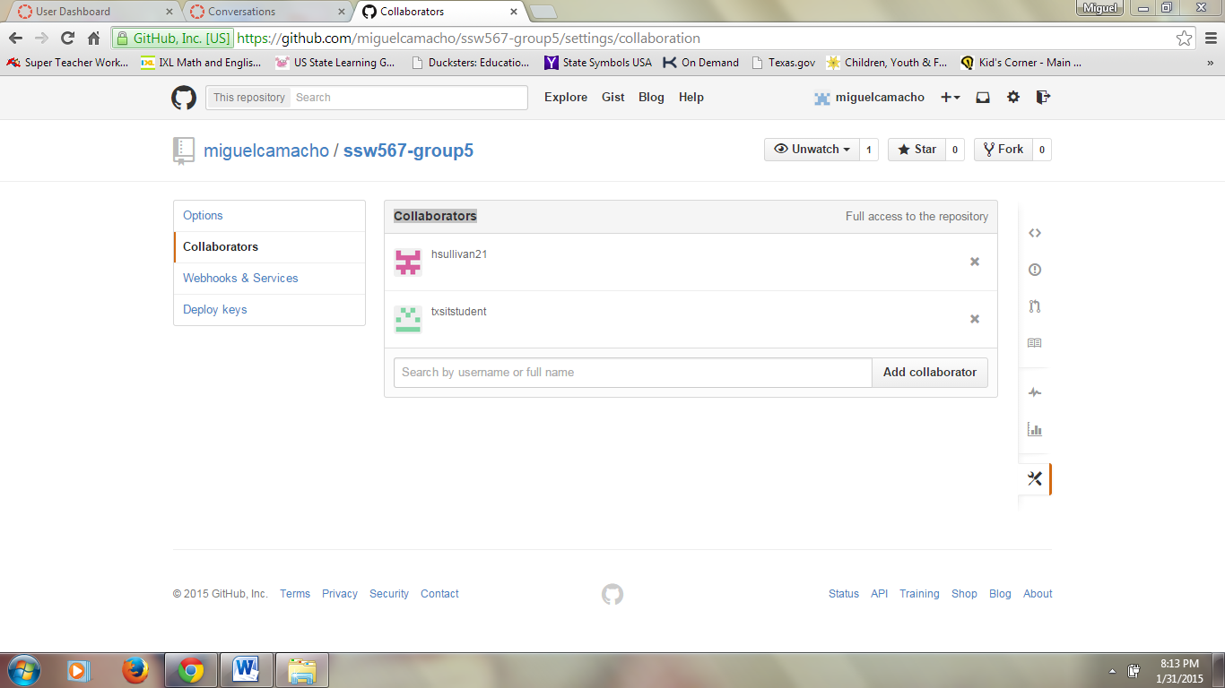

**Group 5 Github Collaborators Screenshot**

**Group Collaboration 3**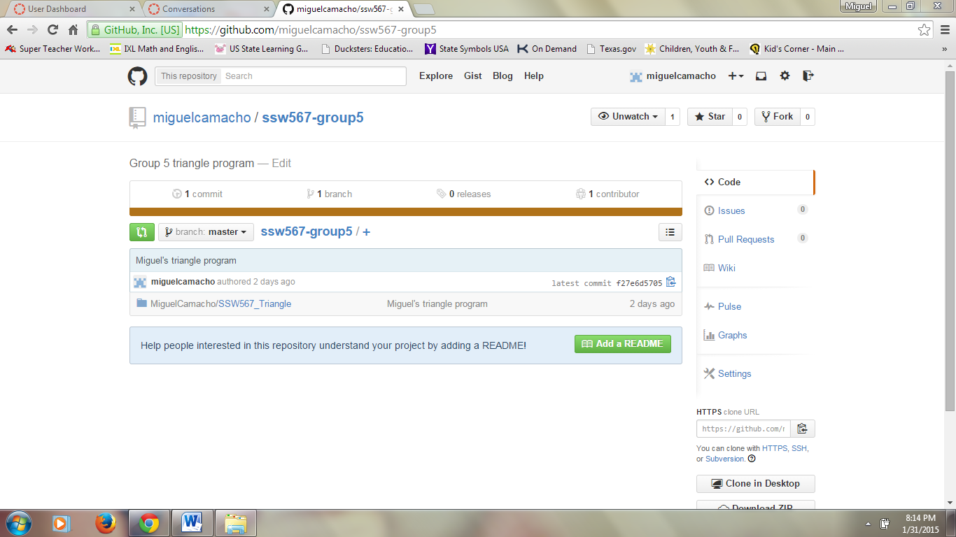

**Group 5 Github Repository**

**Group Collaboration 4**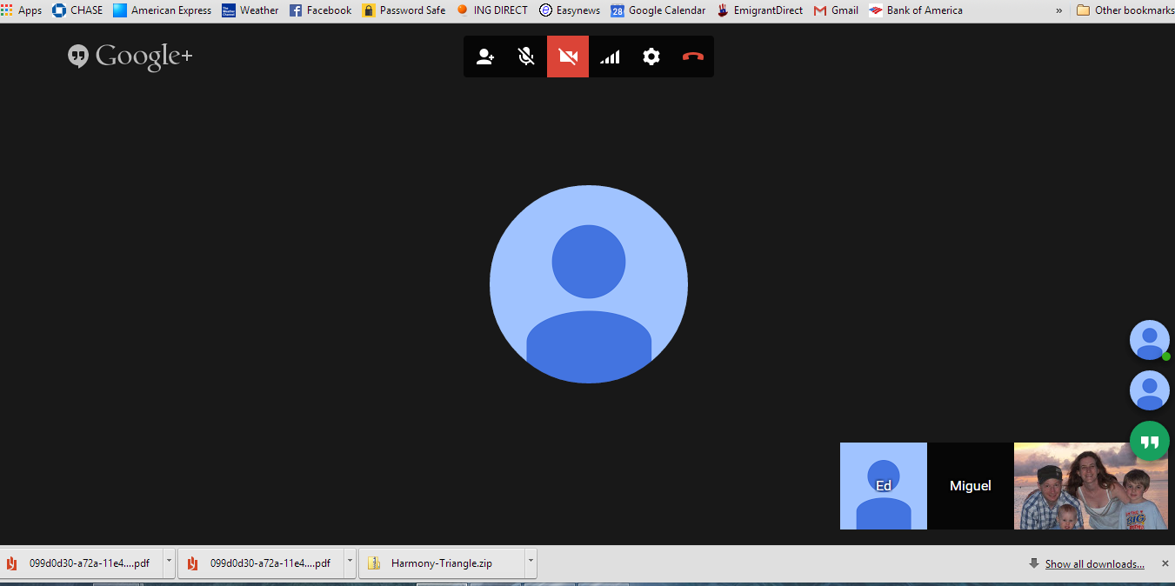

**Group 5 Google Hangout**

**Group Collaboration 5**

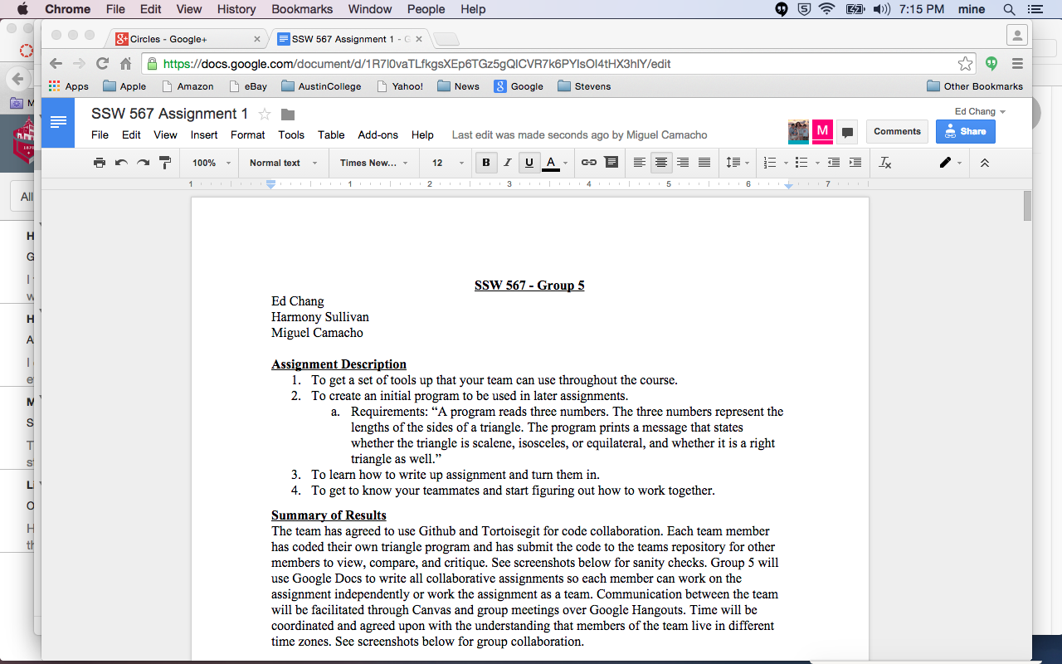

**Group 5 Google Docs**